RE NEWSLETTER –Summer 2 2023
RE CURRICULUM TOPIC THIS HALF TERM -
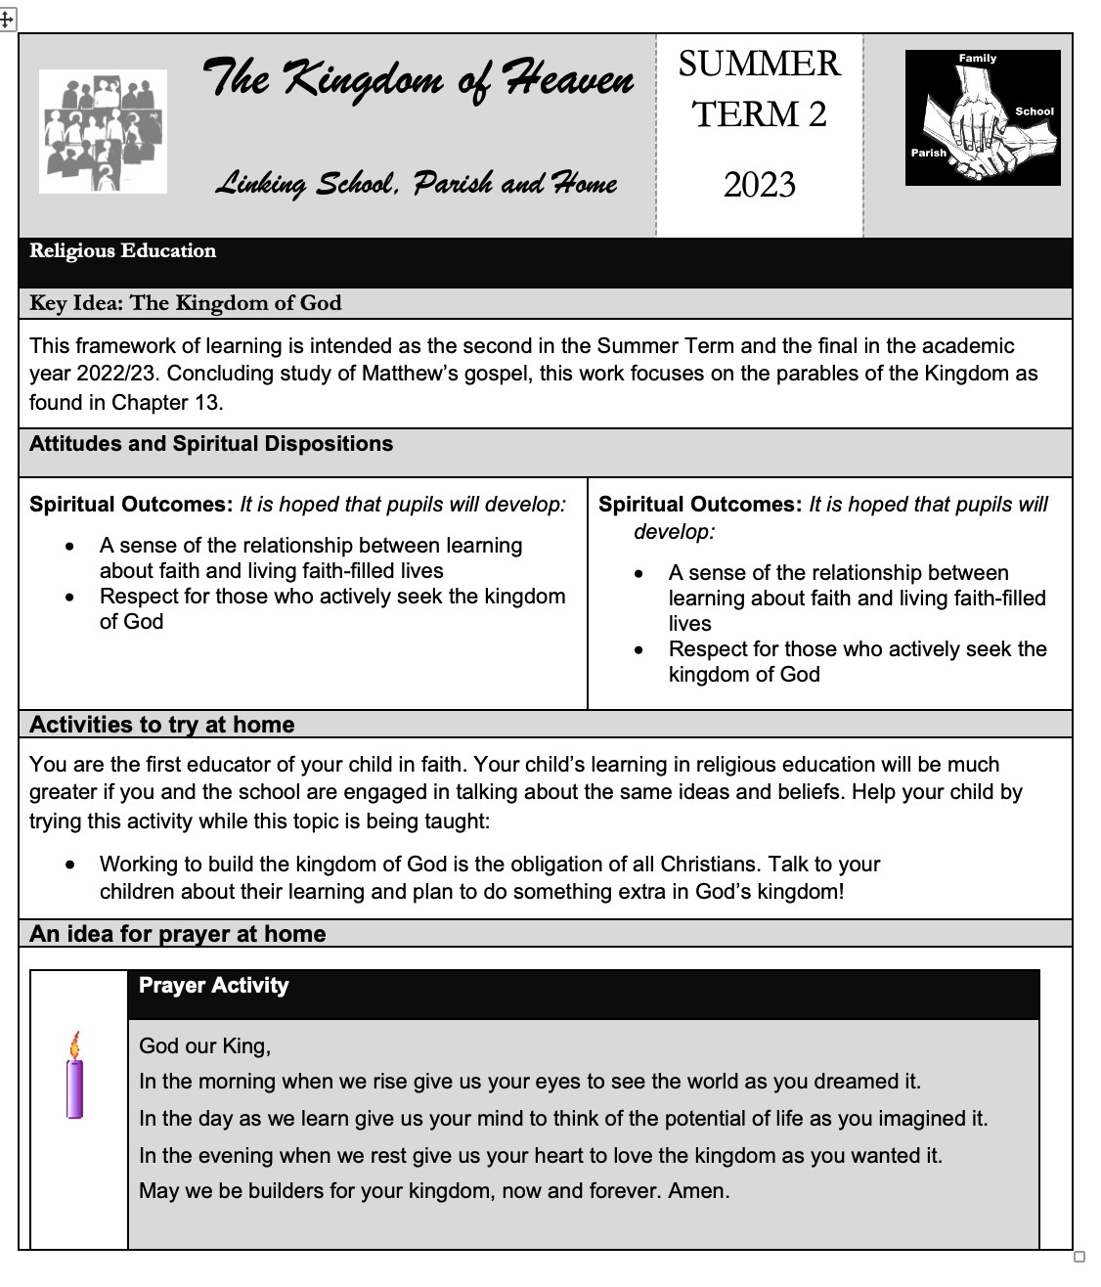

IMPORTANT DATES THIS TERM

28th May – Pentecost
1st June – Our Lord Jesus Christ, Eternal High Priest
4th June – Most Holy Trinity
11th June – Holy Body and Blood of Christ
20th June – St Alban, first martyr of England.
22nd June – St John Fisher and St Thomas More
23rd June – Nativity of St John the Baptist
16th June- Sacred Heart of Jesus
17t^{h} June – Immaculate Heart of the Blessed Virgin Mary
29th June – St Peter and St Paul

School Dates

15th June – All Saints’ Trust Leavers Mass at 1.30pm at English Martyrs
16th June – Year 3 going to mass at English Martyrs
20th June – Year 5 to Brent Deanery Schools’ Mass
28th June - Mass for 50th Anniversary of the School and afternoon tea party
29th June – St Peter and St Paul (Year 4 and Year 2 going to Mass. Mass streamed online for rest of the classes)

VALUES OF THE MONTH

This term the chaplains will be giving out special certificates for children displaying the value each week.

JUNE JULY

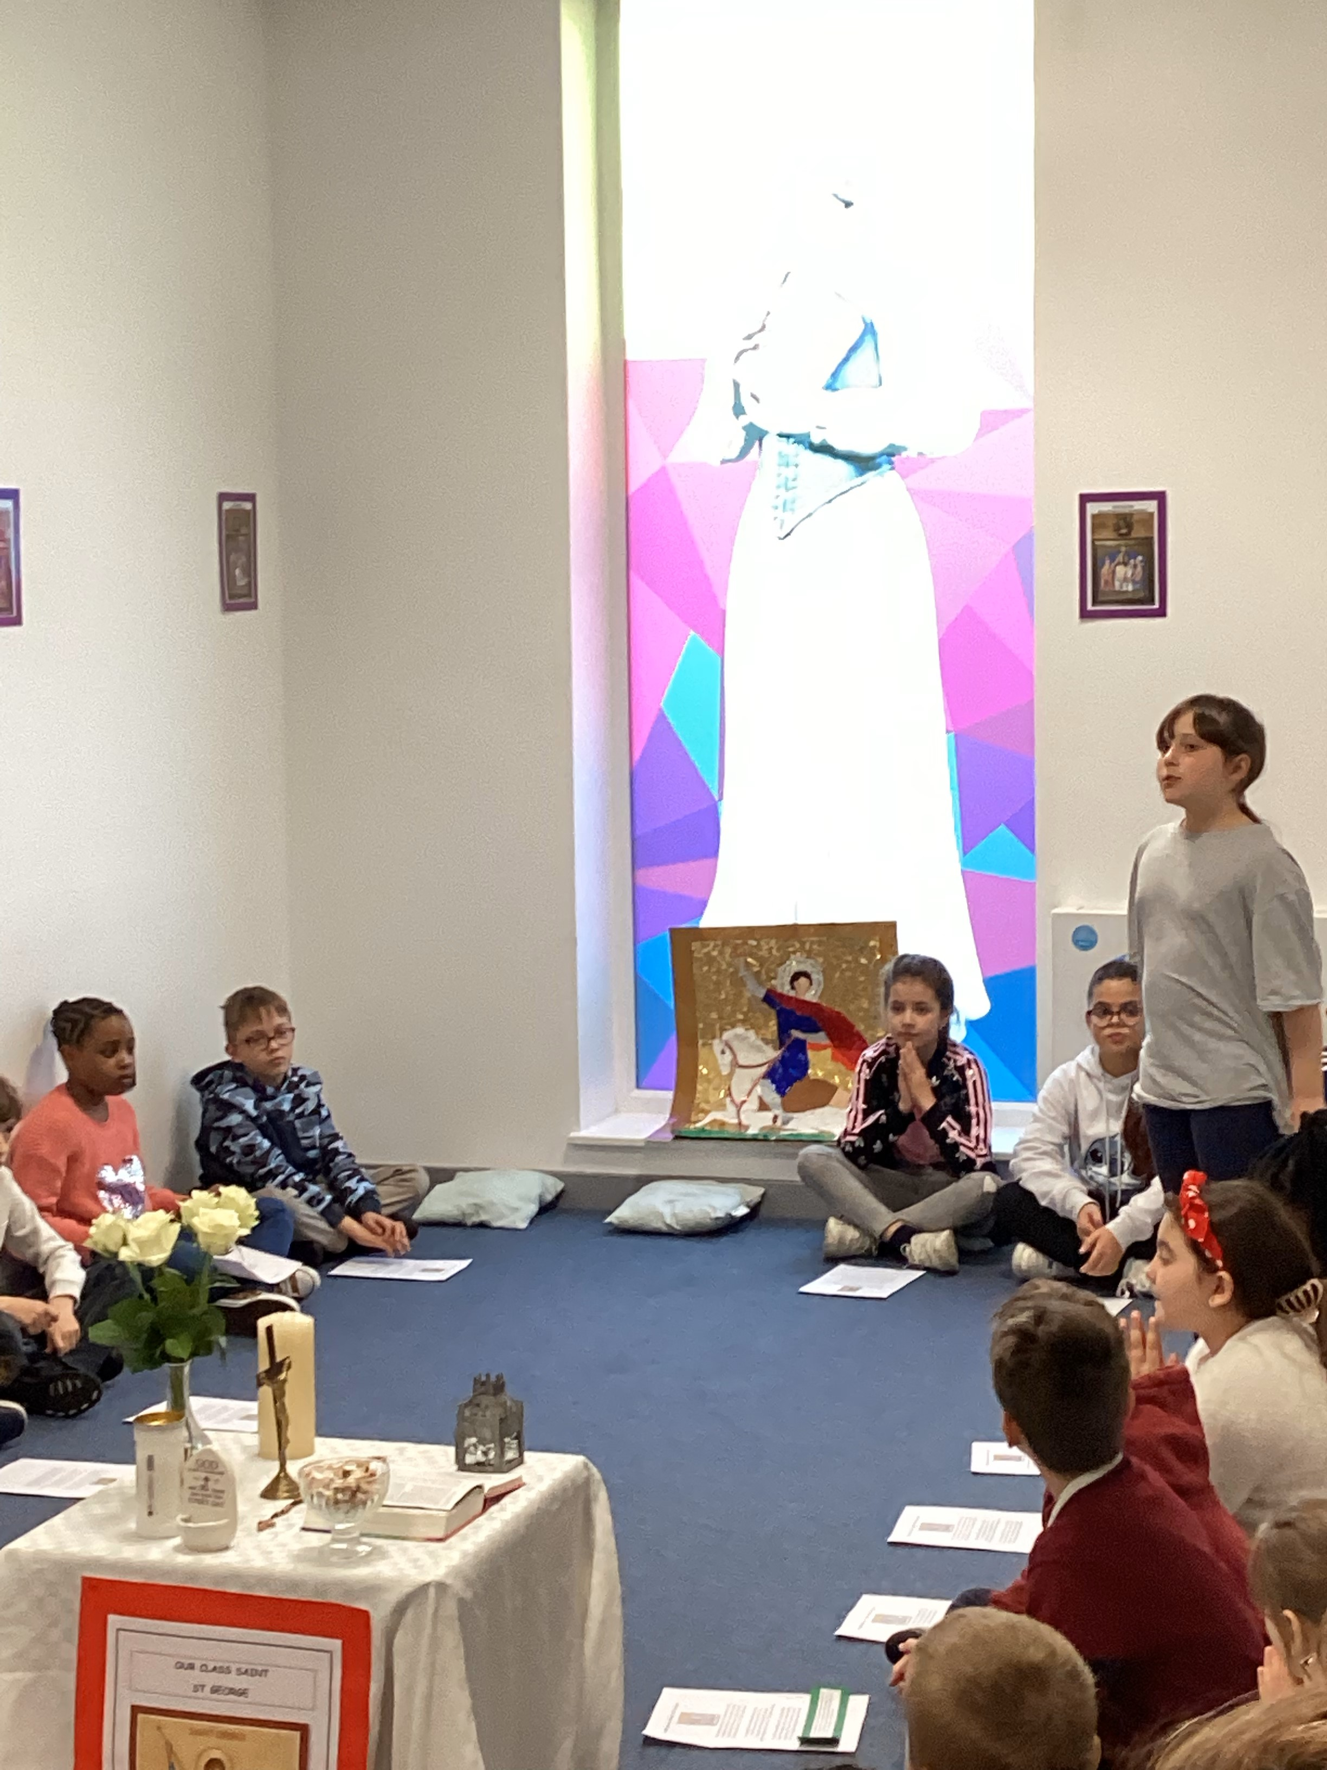
CLASS SAINTS

Reception – St Francis of Assisi
Year 1 – St Patrick
Year 2- St David
Year 3 – St Andrew
Year 4 – St George
Year 5 – St Vincent De Paul
Year 6 – St Martin de Porres

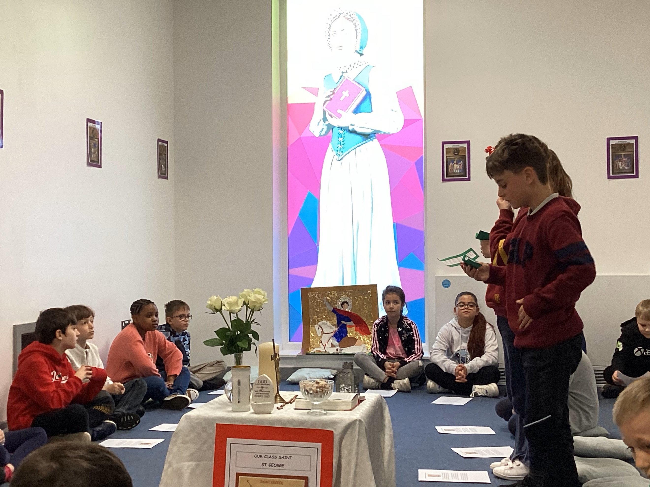

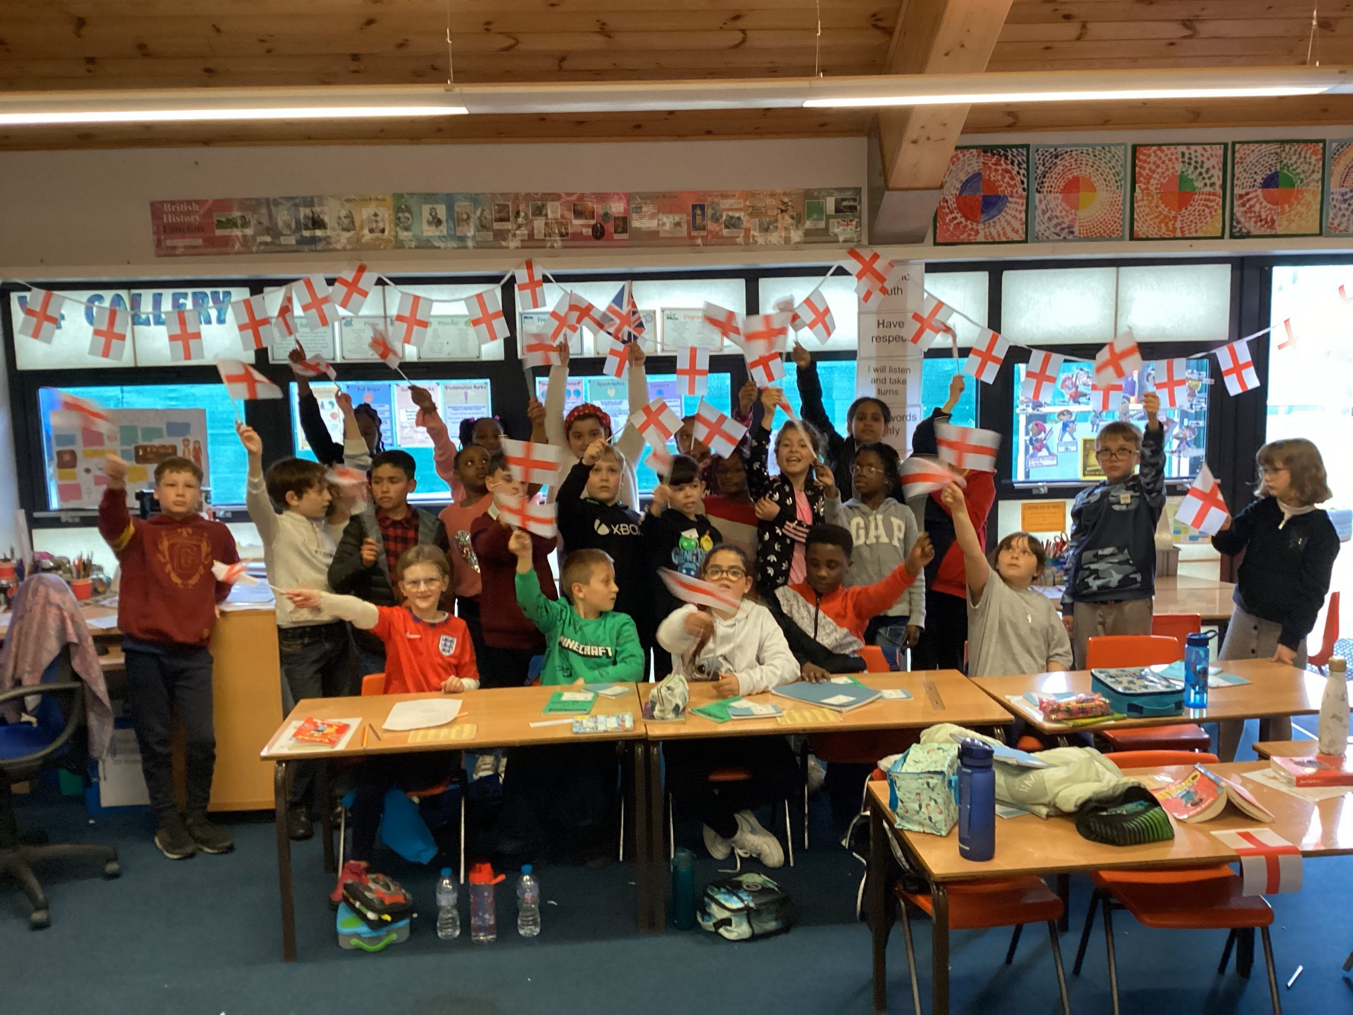

OTHER FAITHS

This term all classes have learnt about Islam. We are very lucky to have a number of Muslim staff and students who shared their faith willingly to support the learning of all children. Children thoroughly enjoyed this topic.

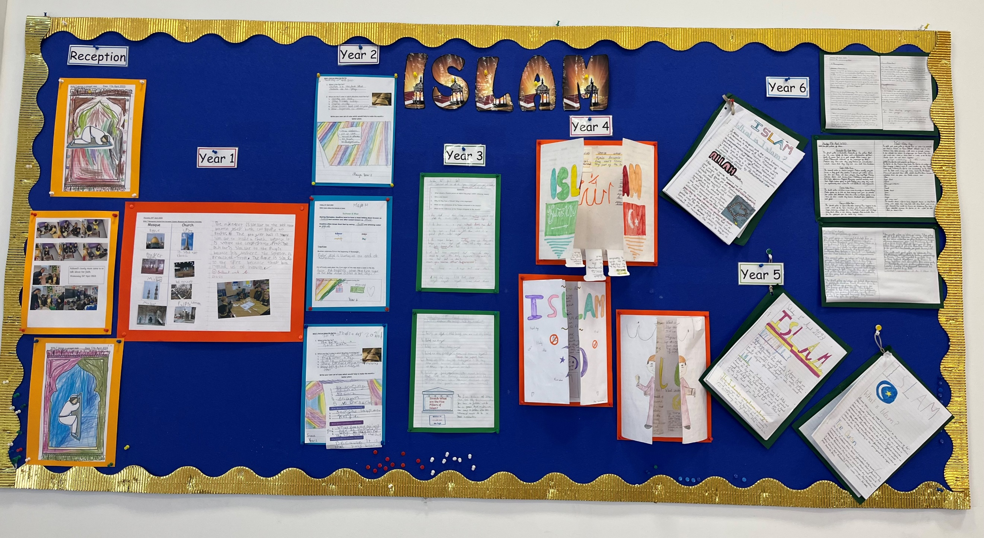

CARITAS IN ACTION

Through our Caritas in Action Programme, we learn about Catholic Social Teaching,

During this term we will be reviewing all the themes of Catholic Social Teaching we have learnt about. These are:
Dignity of the Human Person
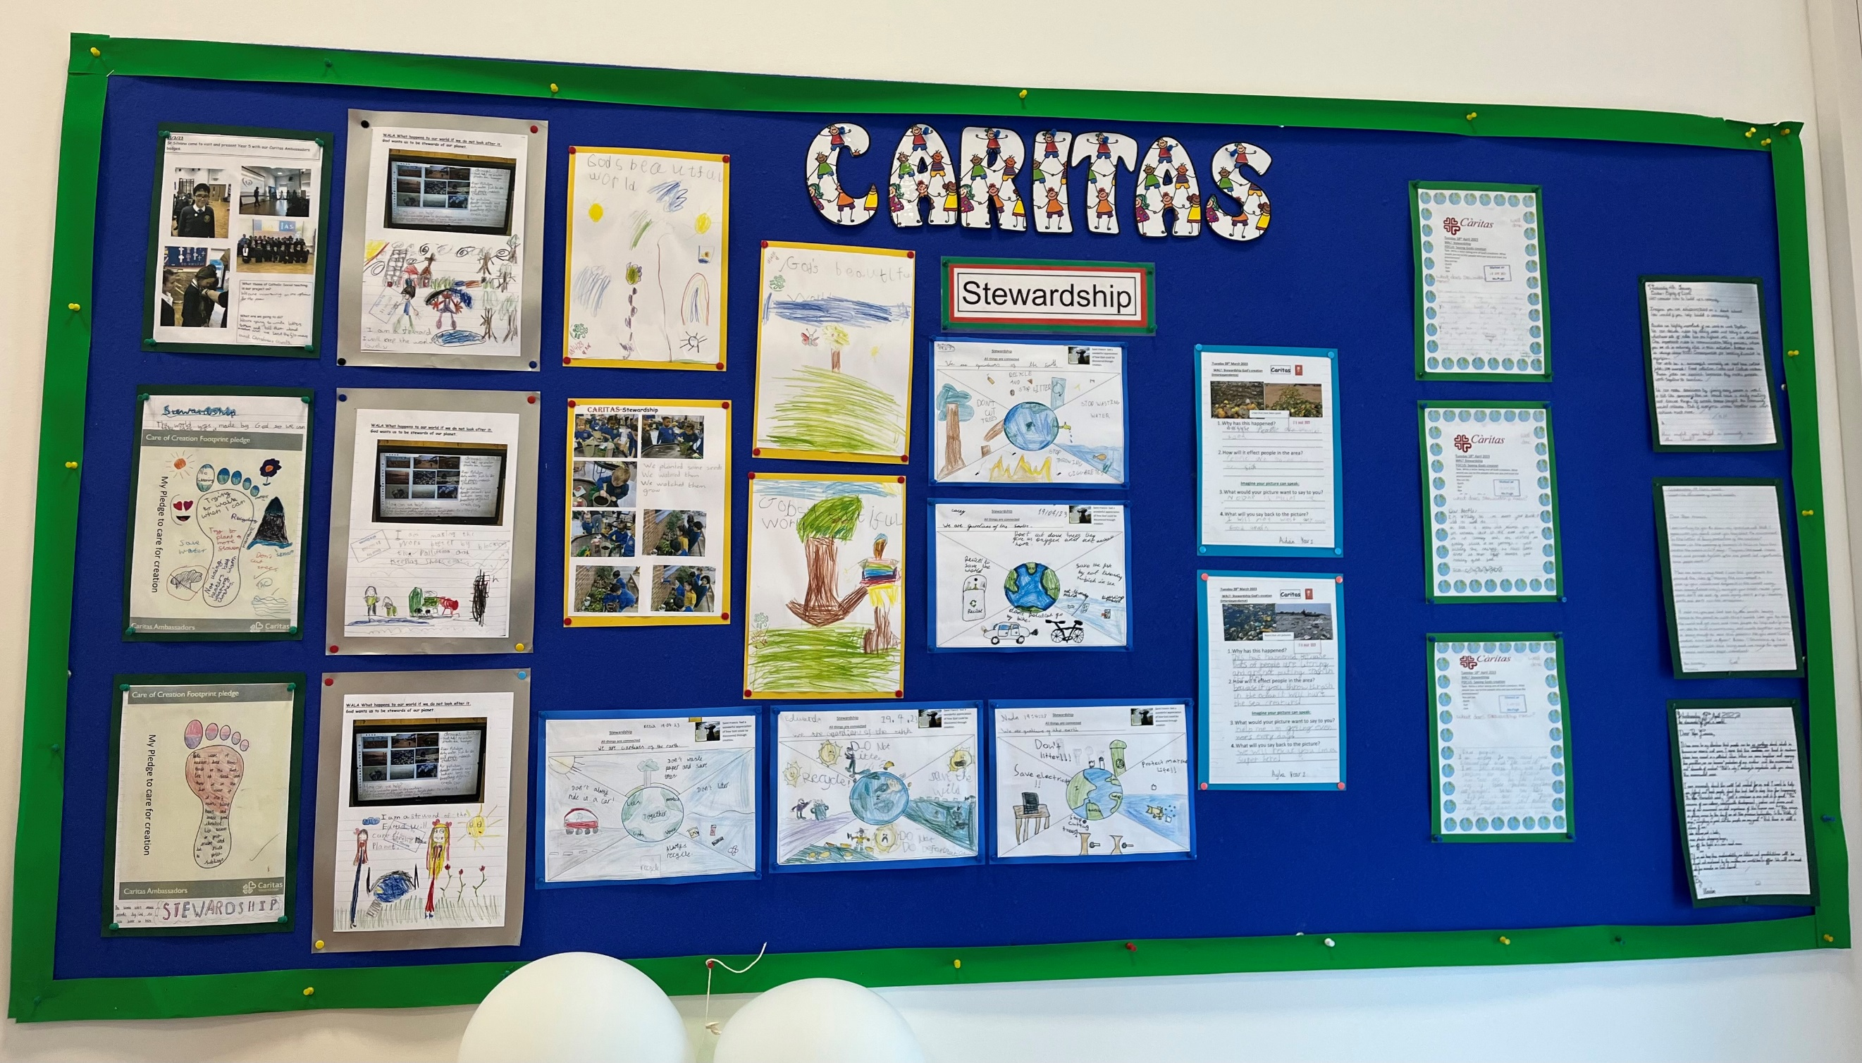
Family and Community
Solidarity and the common good.
Rights and responsibilities
Option for the poor and vulnerable
The dignity of work
Stewardship.

PRAYER CYCLE

During Ordinary Time (Summer), i.e. up to September, we are asked to pray for these intentions:
A Deeper Understanding between Christians and Jews; Those Who Suffer Persecution, Oppression and Denial of Human Rights; Europe; Human Life; Seafarers.
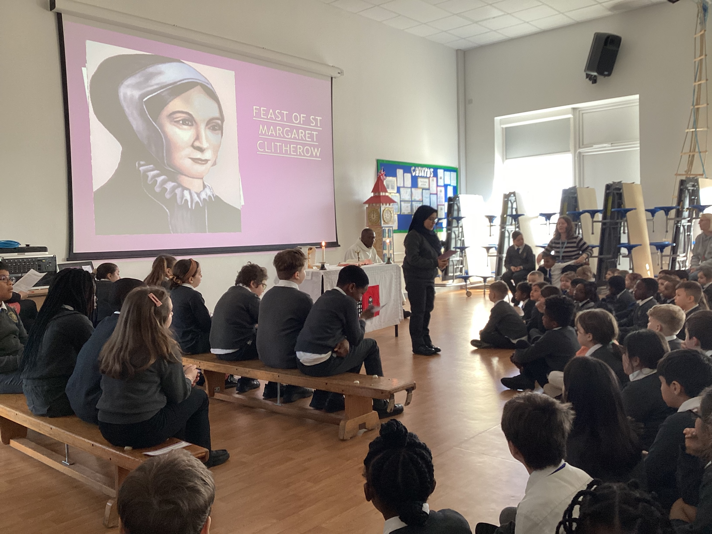

Mass for the feast of St Margaret Clitherow

Mary Prayer Garden

A huge thank you to all the parents who sent in flowers with their children. These have made a beautiful addition to our prayer garden.
