RE NEWSLETTER – AT 1 2022
RE CURRIULUM TOPIC THIS HALF TERM -
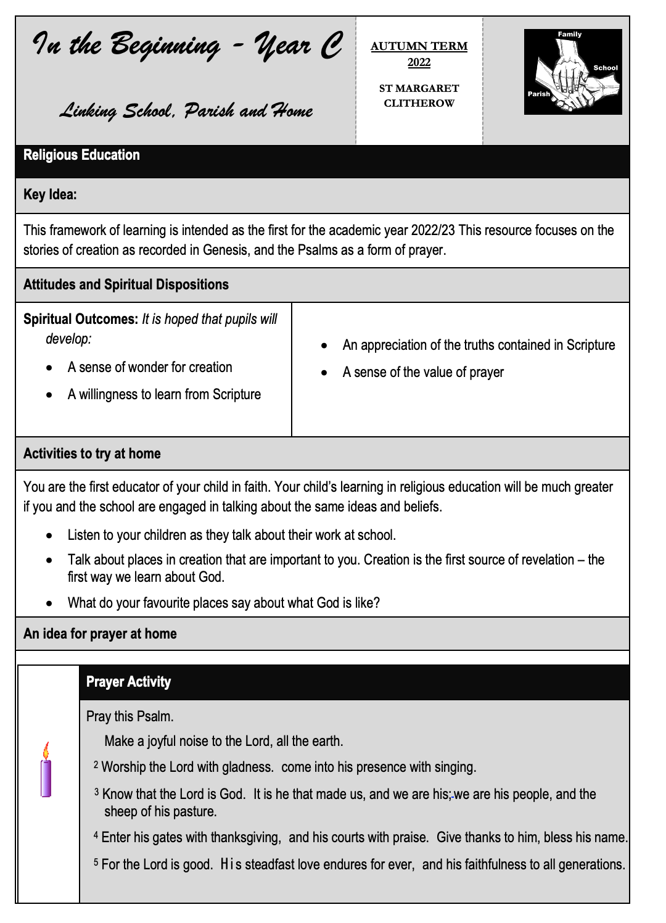

IM

More information on the RE curriculum for each class can be found on the Curriculum Overview and Curriculum Guidelines available on the school website.

IMPORTANT DATES THIS TERM

8th September – Birthday of Blessed Virgin Mary
12th September – Education Sunday
14th September – Exaltation of the Holy Cross
15th September – Our Lady of Sorrows
19th September – Home Mission Day
21st September – St Matthew
24th September – Our Lady of Walsingham
26th September -Harvest Sunday
27th September - St Vincent De Paul
1st October – Harvest Fast Day
4th October – St Francis of Assisi
18th October – St Luke
22nd October – St John Paul II
24th October – World Mission Day

OTHER FAITHS

Our world faith for study this term is Judaism.

CLASS SAINTS

Every class has their own class saint. On the feast day of their saint (or the closest day possible)- they will have a special liturgy and be allowed to wear their own clothes. You will be given further details of this nearer the time.

Reception – St Francis of Assisi
Year 1 – St Patrick
Year 2- St David
Year 3 – St Andrew
Year 4 – St George
Year 5 – St Vincent De Paul
Year 6 – St Martin de Porres

CARITAS IN ACTION

Catholic Social Teaching is based on the belief that God has a plan for creation, a plan to build his kingdom of peace, love and justice.

It holds that God has a special plan for every single one of us, whoever we are. Our part in this plan isn’t just limited to things ‘spiritual’, or times when we do “religious things.” It involves every aspect of our lives, from the things we pray about, to how we live as a responsible global citizen.

Our part in this story is a kind-of vocation for the common good, a call to treat everyone as our brothers and sisters. It is something that we all share.

Our theme for this term is “Option for the poor and vulnerable”.

PRAYER CYCLE

October is the month of the Rosary.
During Ordinary Time (Autumn), i.e. from September to Christ the King, we are asked to pray for these intentions: Students and Teachers; The Spread of the Gospel; The Harvest; the Fruits of Human Work, and the Reverent Use of Creation; Justice and Peace in the World; All Victims of War; Young People; Prisoners and their Families.
COLLECTIVE WORSHIP

This year we will be using the resources from “Ten Ten” to support our Collective Worship. Children will attend whole school worship on Monday morning linked to the Gospel and prayer throughout the week will be linked to this. In addition, children will attend hymn practice and a whole school or class assembly on a Friday. One prayer session in class this week will be using the Mark 10 mission resources linked to the Gospel and one session will be prepared and led by the children. In addition, each class has set prayers they will be using throughout the day as well as prayers from the mass they will be trying to learn.
Each class has a prayer book that comes home for children to share their prayers in. For more details please see the RE section of our website.

PUPIL CHAPLAINS

St Margaret Clitherow school has a team of dedicated Pupil Chaplains who promote the Catholic Ethos our school. The role is available to children in Year 5 and 6.
Pupil Chaplaincy has a high profile in our school. Each one of the Pupil Ch​aplains must apply for this important role and is interviewed. Following the interviews, the Pupil Chaplains are commissioned by our Parish Priest, in a school mass.
Our Pupil Chaplains are a very dedicated team who have a vital role in enhancing the Religious Life of our school. Their roles include delivering class and lunchtime Prayer and Worship, leading prayers and reflections in assemblies and Liturgical events, supporting charities and fundraising events.

CREATIVE CHALLENGE

This half term we will be running a competition for children to create a special project at home. The theme in Nursery to Year 2 will be “Creation Mobiles” and the theme in Years 3 to 6 will be to create their own rosaries. These will be displayed around the school and extra silver time awarded to every child who participates.

Some ideas for creation mobiles can be found below.
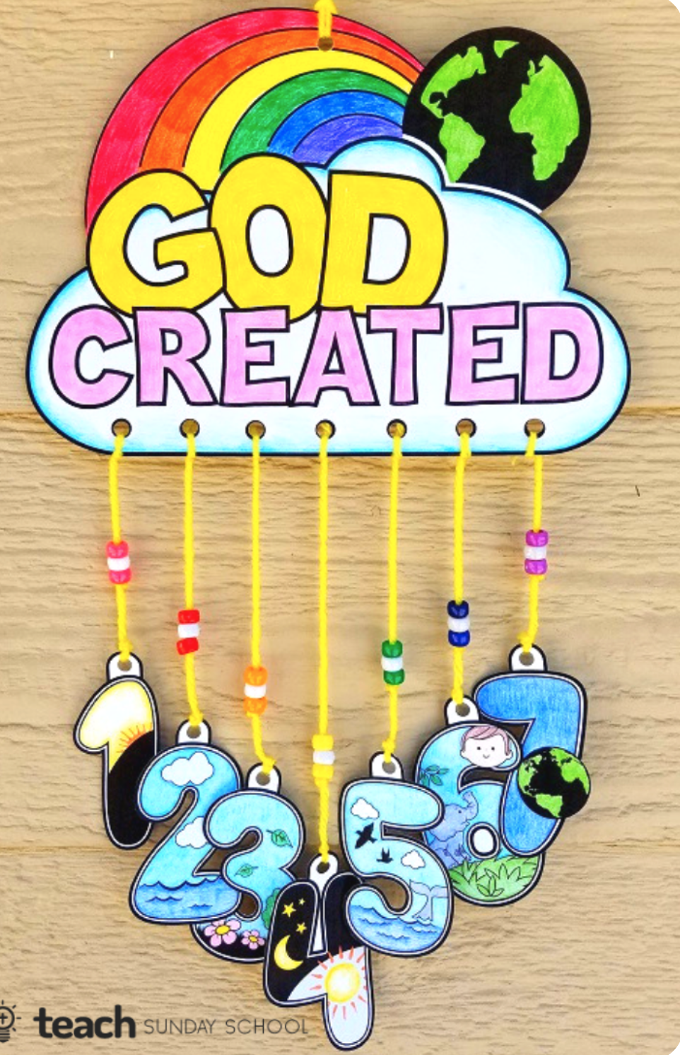
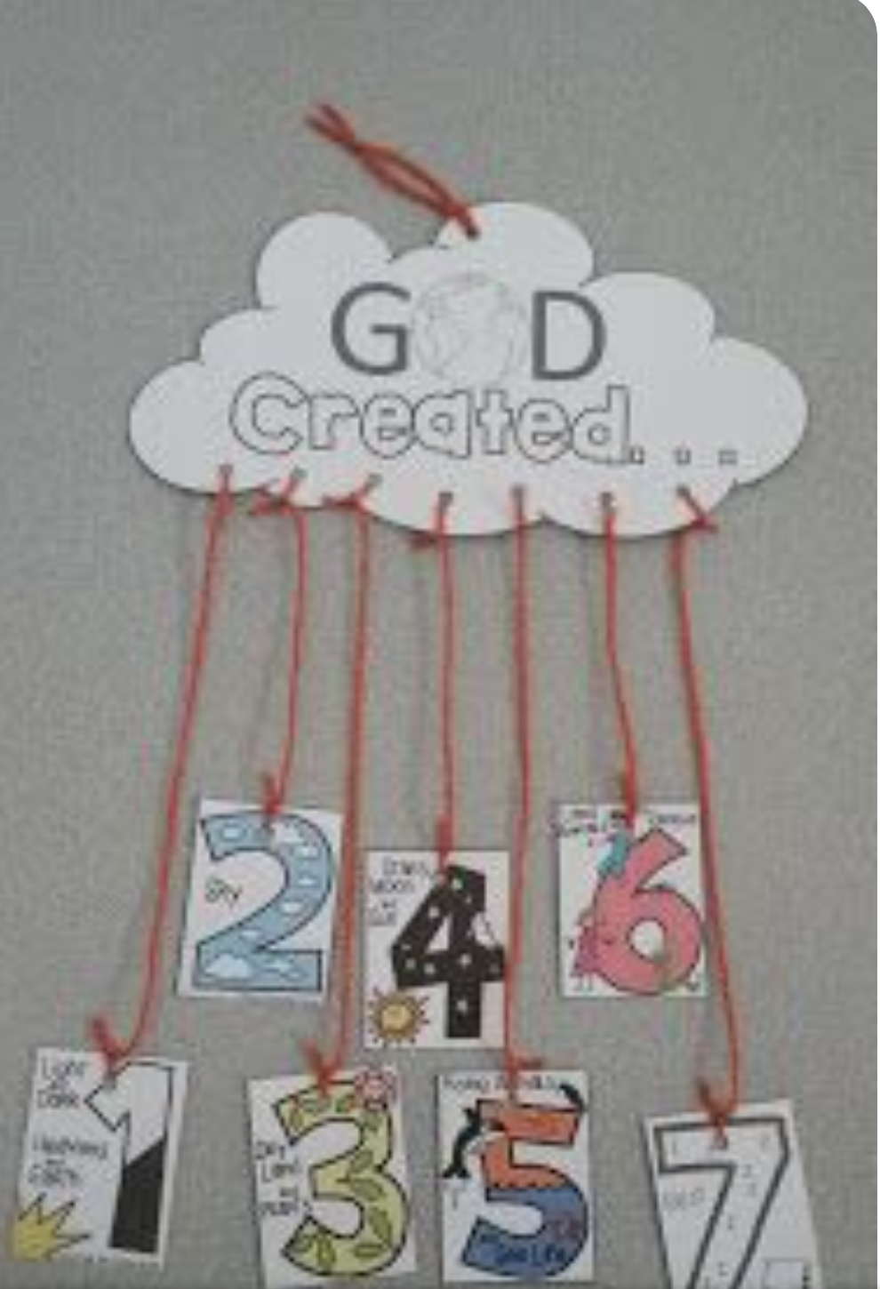
https://christianpreschoolprintables.com/creation-preschool-printables/7-days-of-creation-craft-globe/

For Rosary beads you can use conkers, beads, pasta, pom poms etc- anything you like!
Good luck! Please bring your completed items to school by Monday 17th October.

If you have any questions about this challenge, then please email sterry@clitherow.brent.sch.uk

