RE NEWSLETTER – AUTUMN 2 2022
RE CURRICULUM TOPIC THIS HALF TERM -

From Advent to Christmas  Linking School, Parish and Home | ST MARGARET CLITHEROW AUT2 2022
Religious Education
Key Idea: From Advent to Christmas
This resource focuses on the season of Advent as the time of preparation for the celebration of Christmas. It includes teaching on the ‘O’ Antiphons and Matthew’s account of the birth of Jesus.
Attitudes and Spiritual Dispositions
It is hoped that pupils will develop:  - An appreciation of the gift of God’s presence born again into the world at Christmas  - An openness to the incarnation in their own lives | - An appreciation of the truths contained in Scripture  - A willingness to pray during Advent
Activities to try at home
You are the first educator of your child in faith. Your child’s learning in religious education will be much greater if you and the school are engaged in talking about the same ideas and beliefs.
- Your children are going to be considering how belief that Jesus is God, makes celebrating Christmas different.
- As you prepare for Christmas, think about what you do. What place does belief that God came to live among us have in your Christmas?
An idea for prayer at home
Prayer Activity
God of life,
Open our eyes Lord, to the coming of your light. Help us grow in hope and give us the courage to hope for your presence in our hearts, hope for your peace in our world and hope for your promise in our lives.
We ask this through Christ whose birth we are waiting for!
Amen

IMPORTANT DATES THIS TERM

1st November – All Saints
2nd November – All Souls
3rd November – St Martin de Porres
14th November – Remembrance Day
14th November – World Day of the Poor
21st November – Christ the King
28th November – 1st Sunday of Advent
8th December – Immaculate Conception
10th December – Our Lady of Loreto
3rd December – Migrants Day

CLASS SAINTS

Reception – St Francis of Assisi
Year 1 – St Patrick
Year 2- St David
Year 3 – St Andrew
Year 4 – St George
Year 5 – St Vincent De Paul
Year 6 – St Martin de Porres

CARITAS IN ACTION

This year we are continuing our special programme of Catholic Social Teaching. Catholic Social Teaching is based on the belief that God has a plan for creation, a plan to build his kingdom of peace, love and justice.

It holds that God has a special plan for every single one of us, whoever we are. Our part in this plan isn’t just limited to things ‘spiritual’, or times when we do “religious things.” It involves every aspect of our lives, from the things we pray about, to how we live as a responsible global citizen.

Our part in this story is a kind-of vocation for the common good, a call to treat everyone as our brothers and sisters. It is something that we all share.

Our theme for this term is “The Dignity of Work”.

Please see below some of our work from last half term on “Option for the poor and Vulnerable”
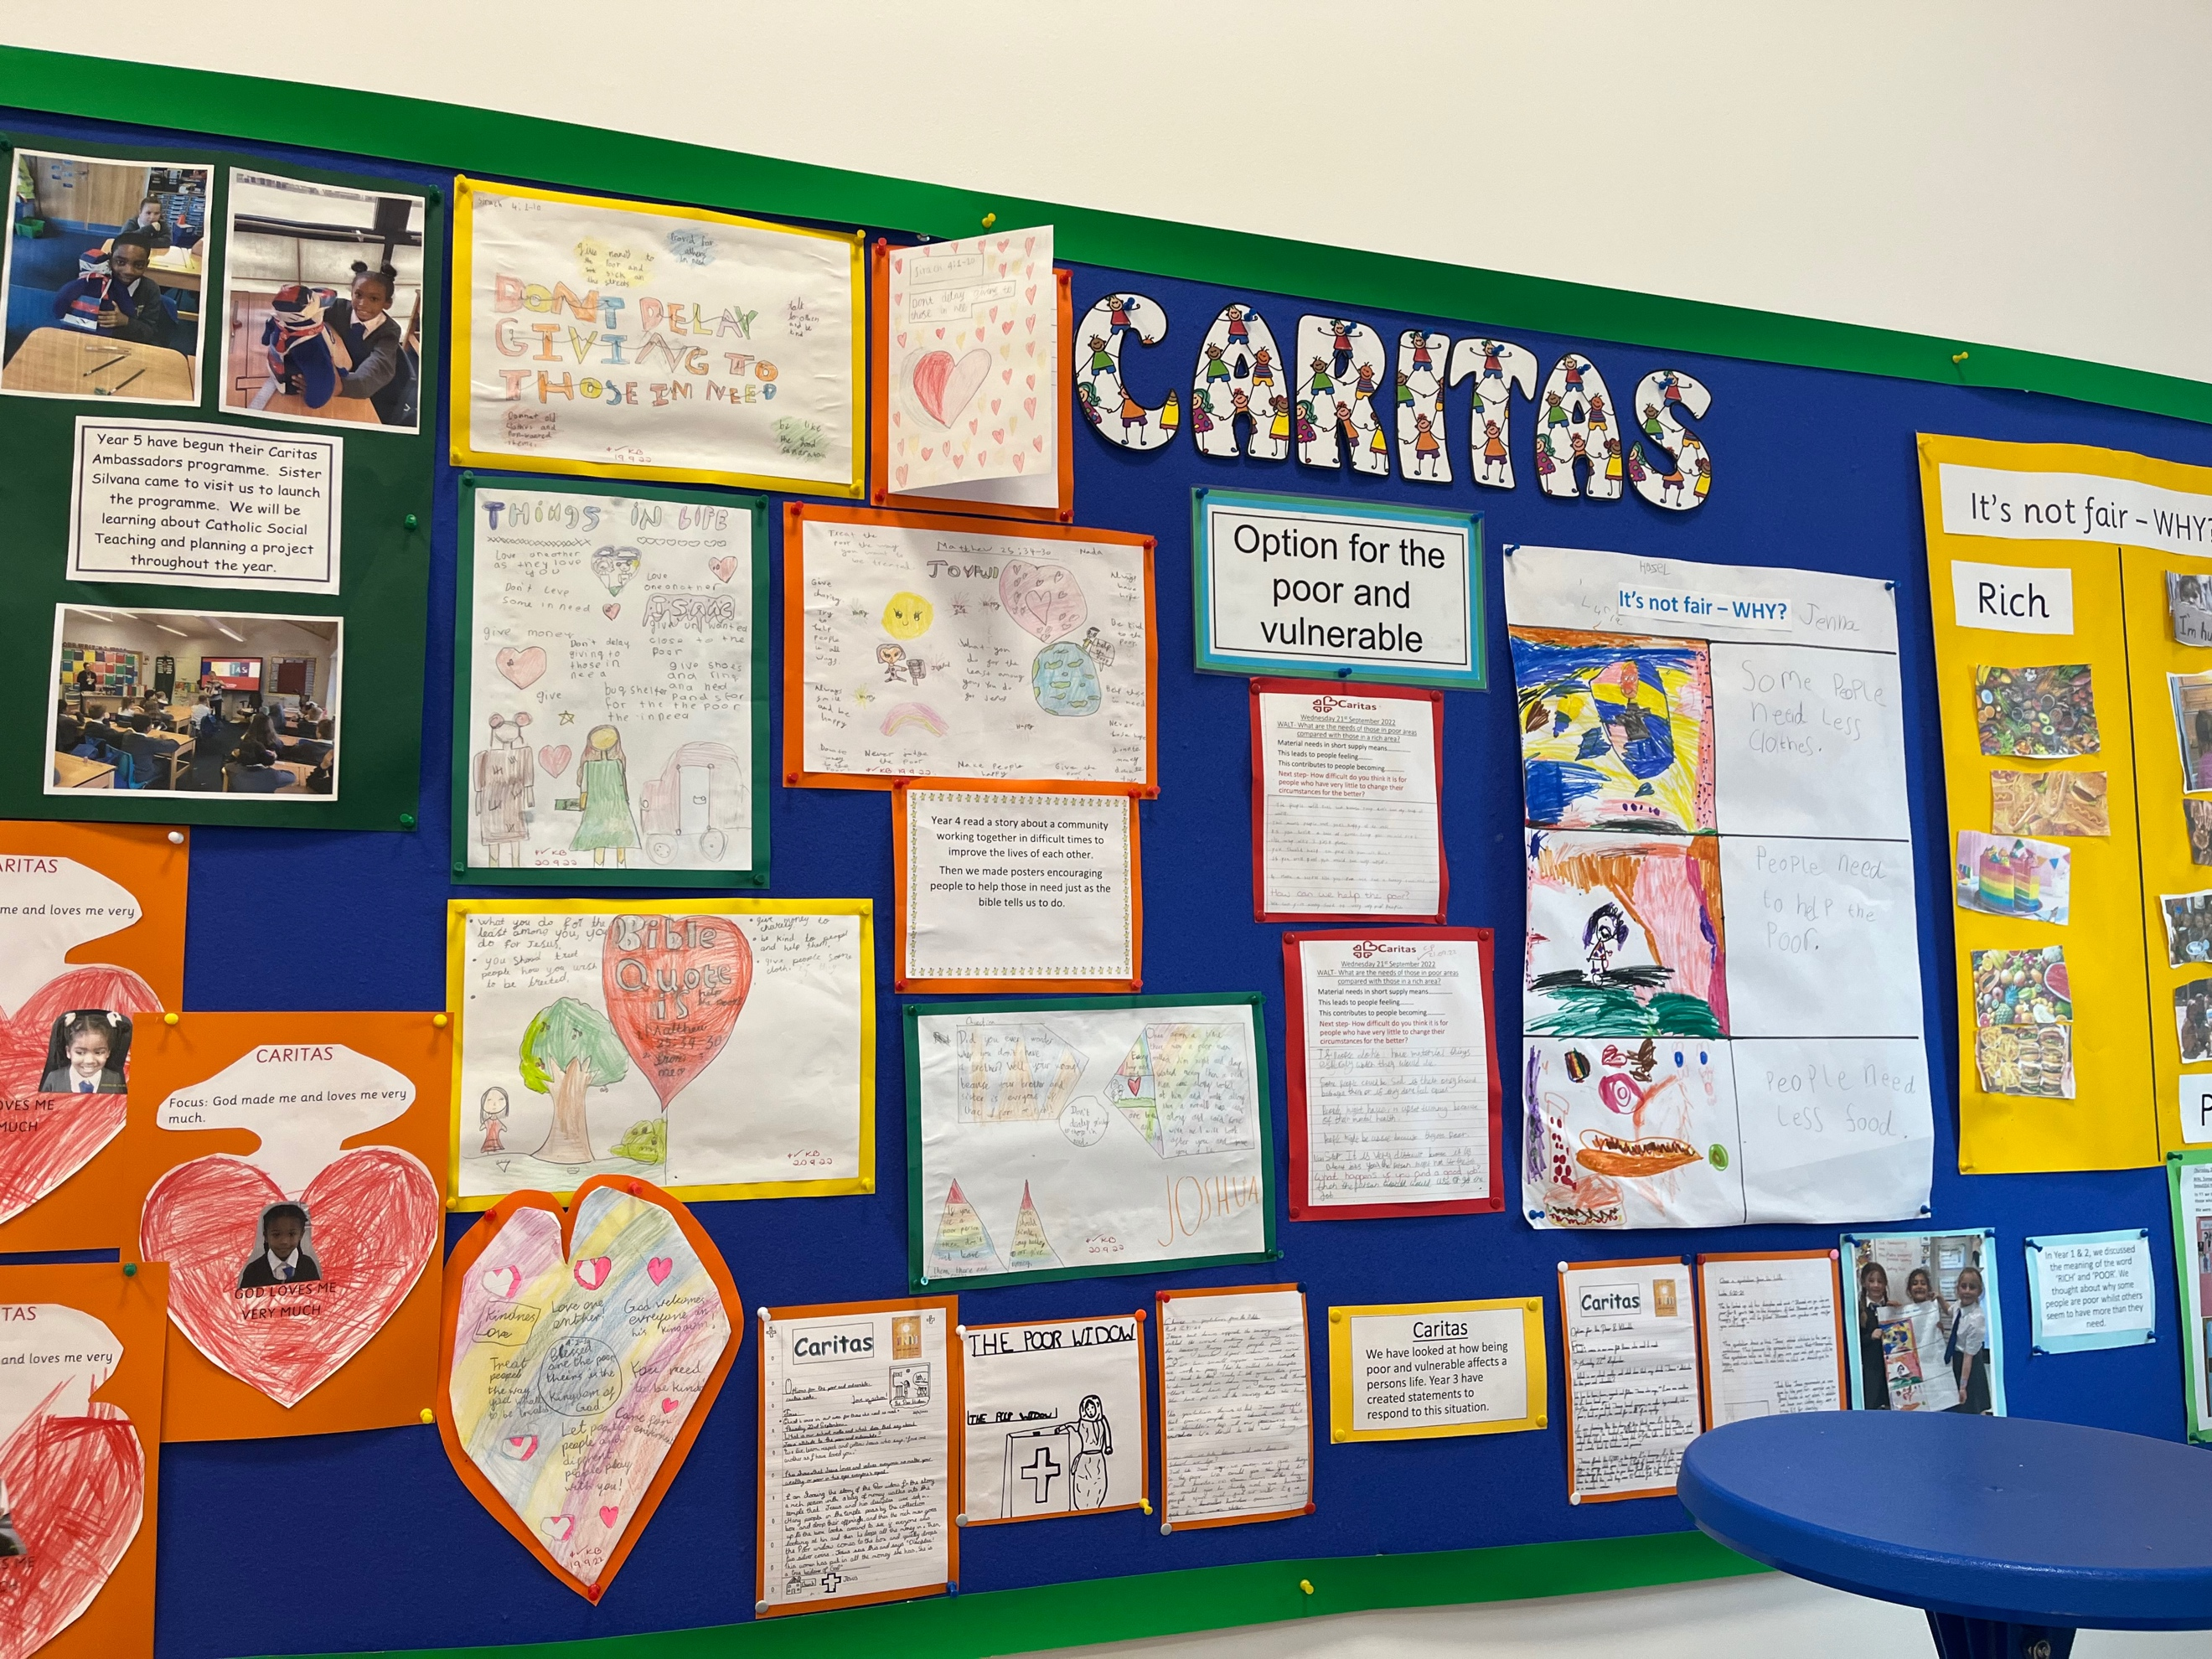

PRAYER CYCLE
During Advent and Christmastide, we are asked to pray for these intentions
Migrants and Refugees, Expectant Mothers.
This term we will be celebrating the following liturgies:
- 3rd November - Year 6 Liturgy for feast of St Martin de Porres and own clothes day
- 3rd November - Year 4 going to Mass at English Martyrs TBC
- Advent Liturgies – Tuesday 29th November
- 30th November - Year 3 Liturgy for the feast of St Andrew
- Confessions for children in Year 4-6 dates TBC
- Christmas Concerts: Thursday 8th December -Reception at 10am
- Christmas Concerts: Thursday 8th December - Year 1 and 2 at 11am
- Christmas Concerts: Thursday 8th December - Year 3 and 4 at 2.15pm
- Christmas Concerts: Thursday 15th December -Year 5 and 6 at 9.30am
- Christmas Concerts: Thursday 15th December - Nursery -11am

CREATIVE CHALLENGE

Well done to the children who created some wonderful dioramas this term.
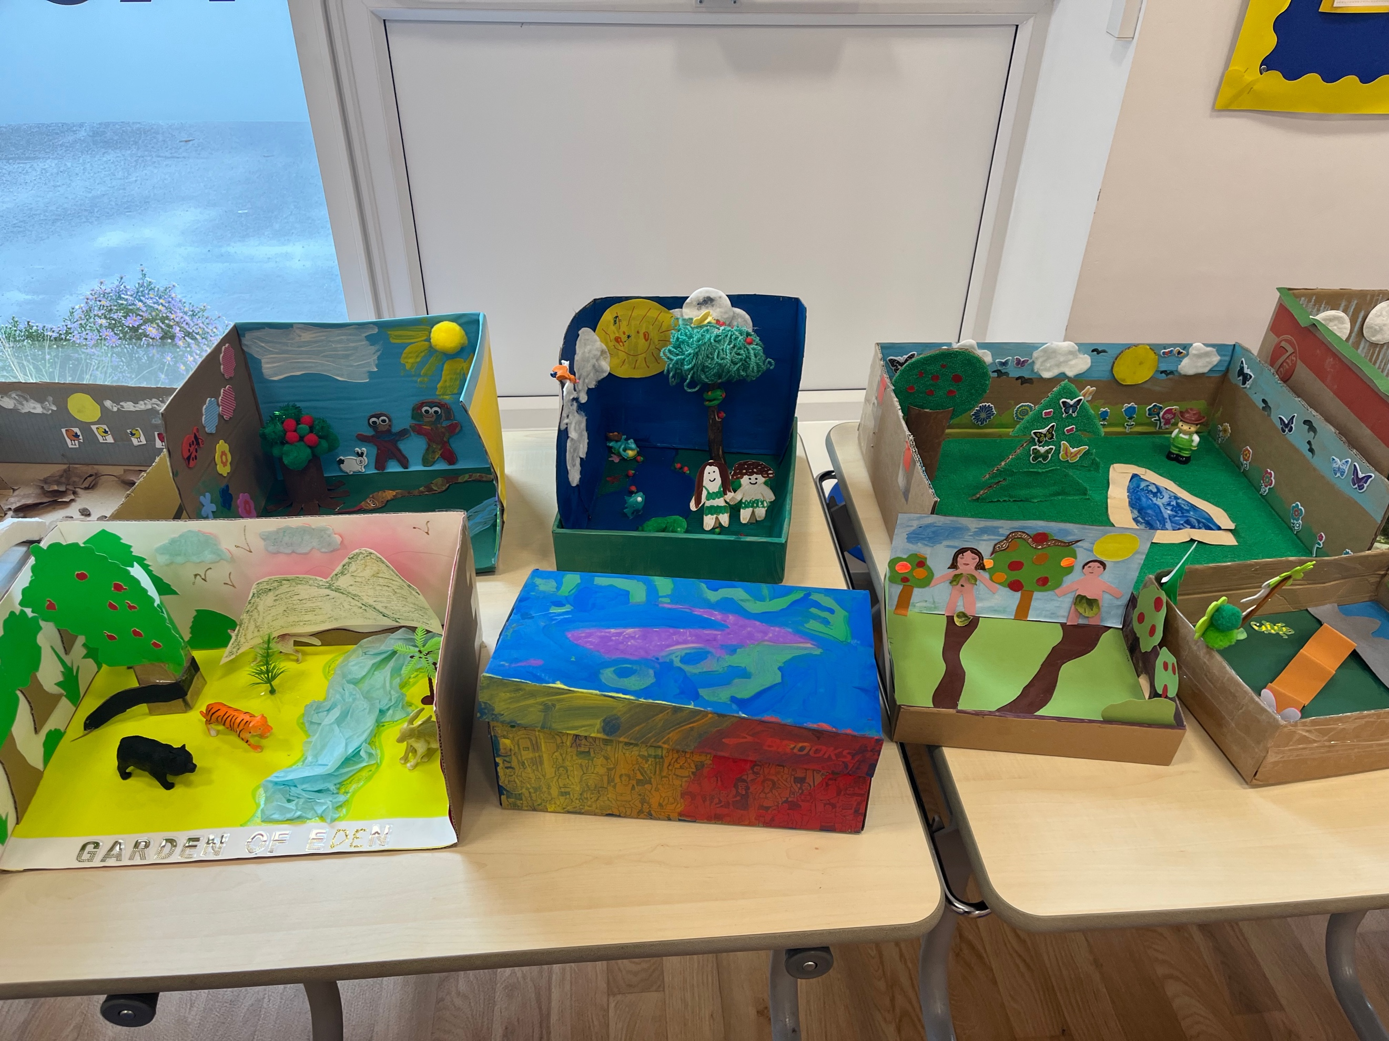
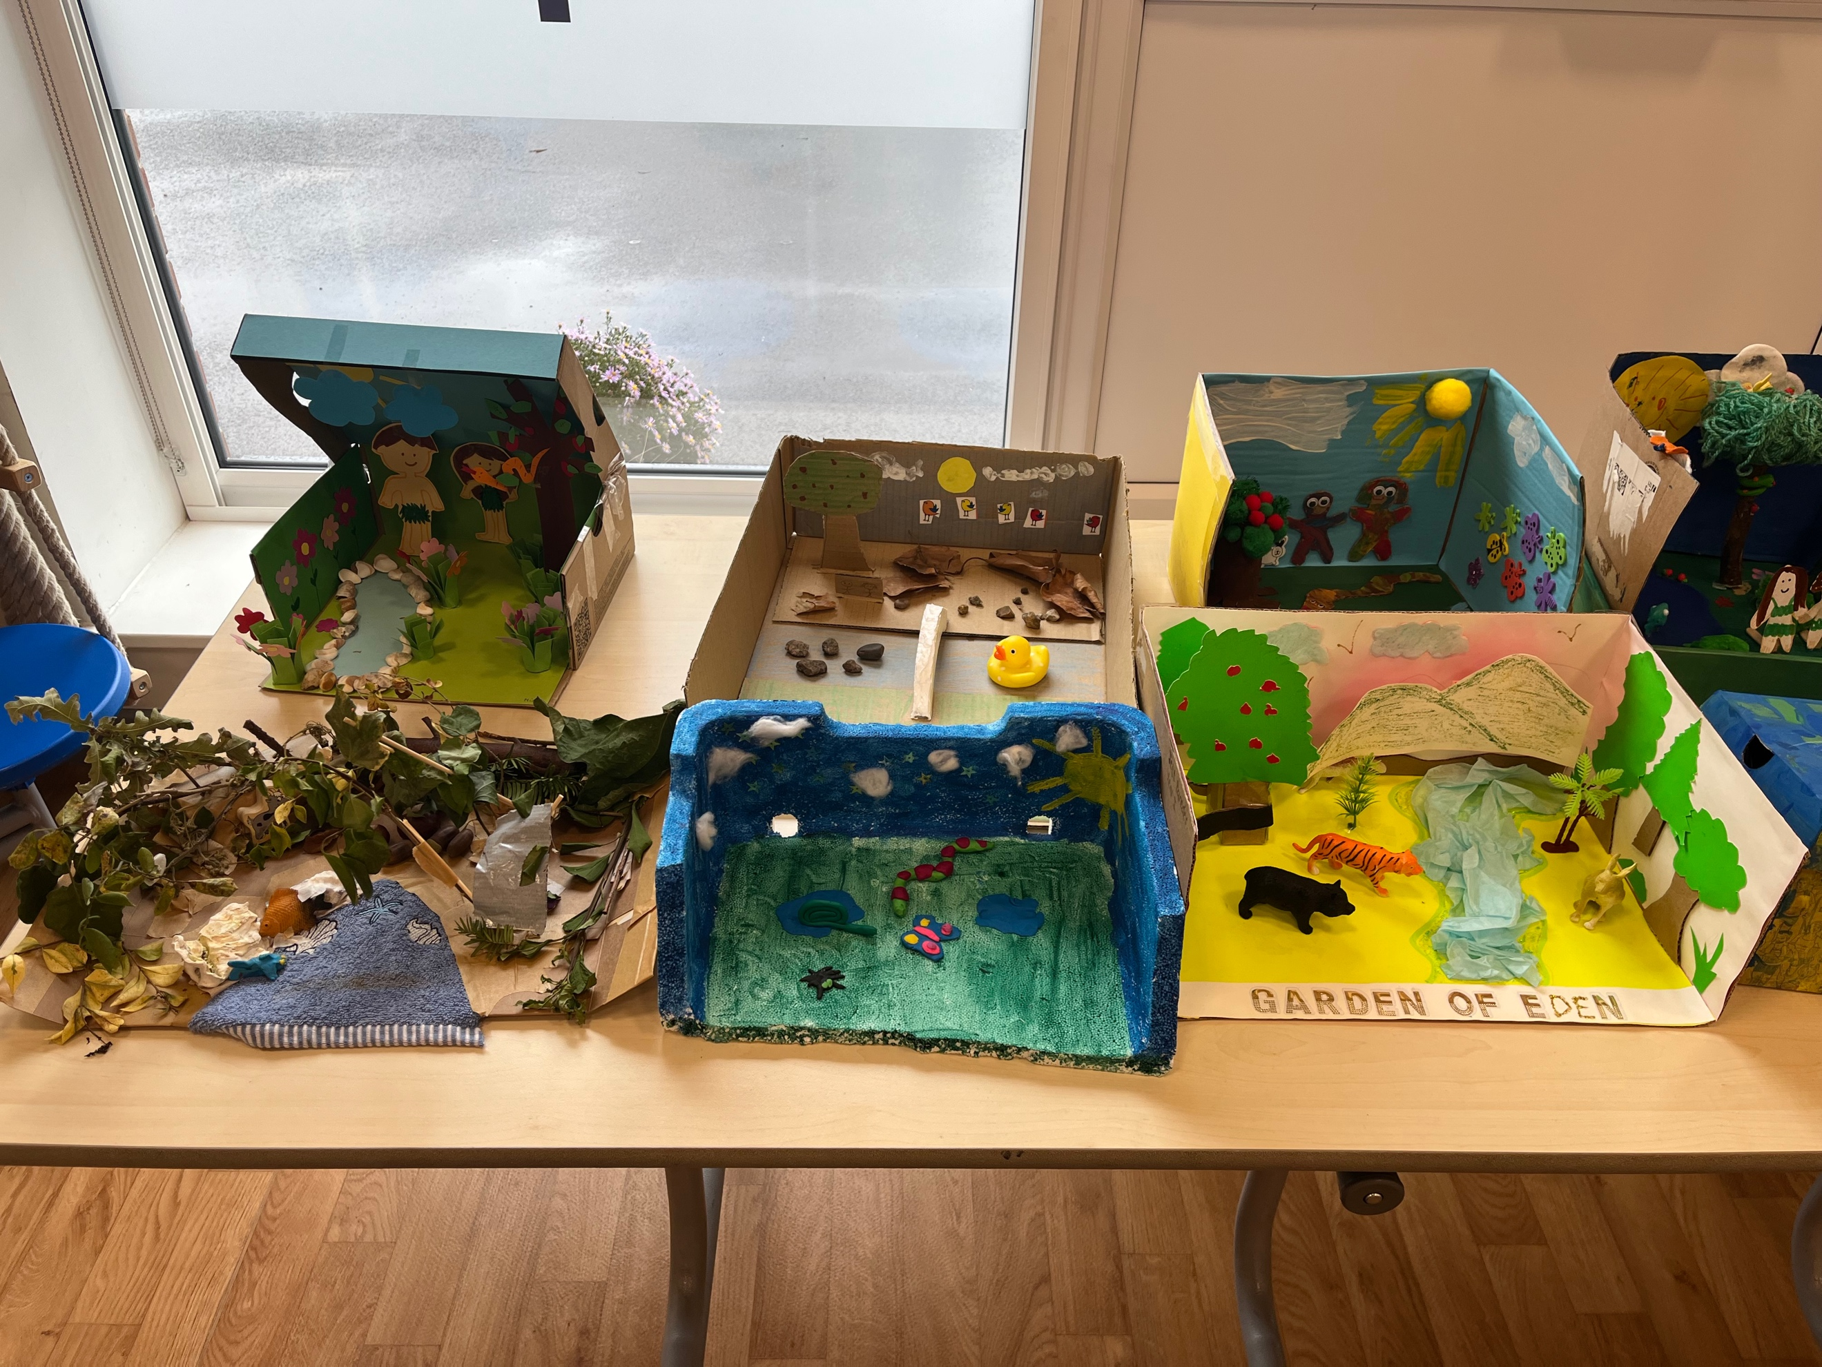

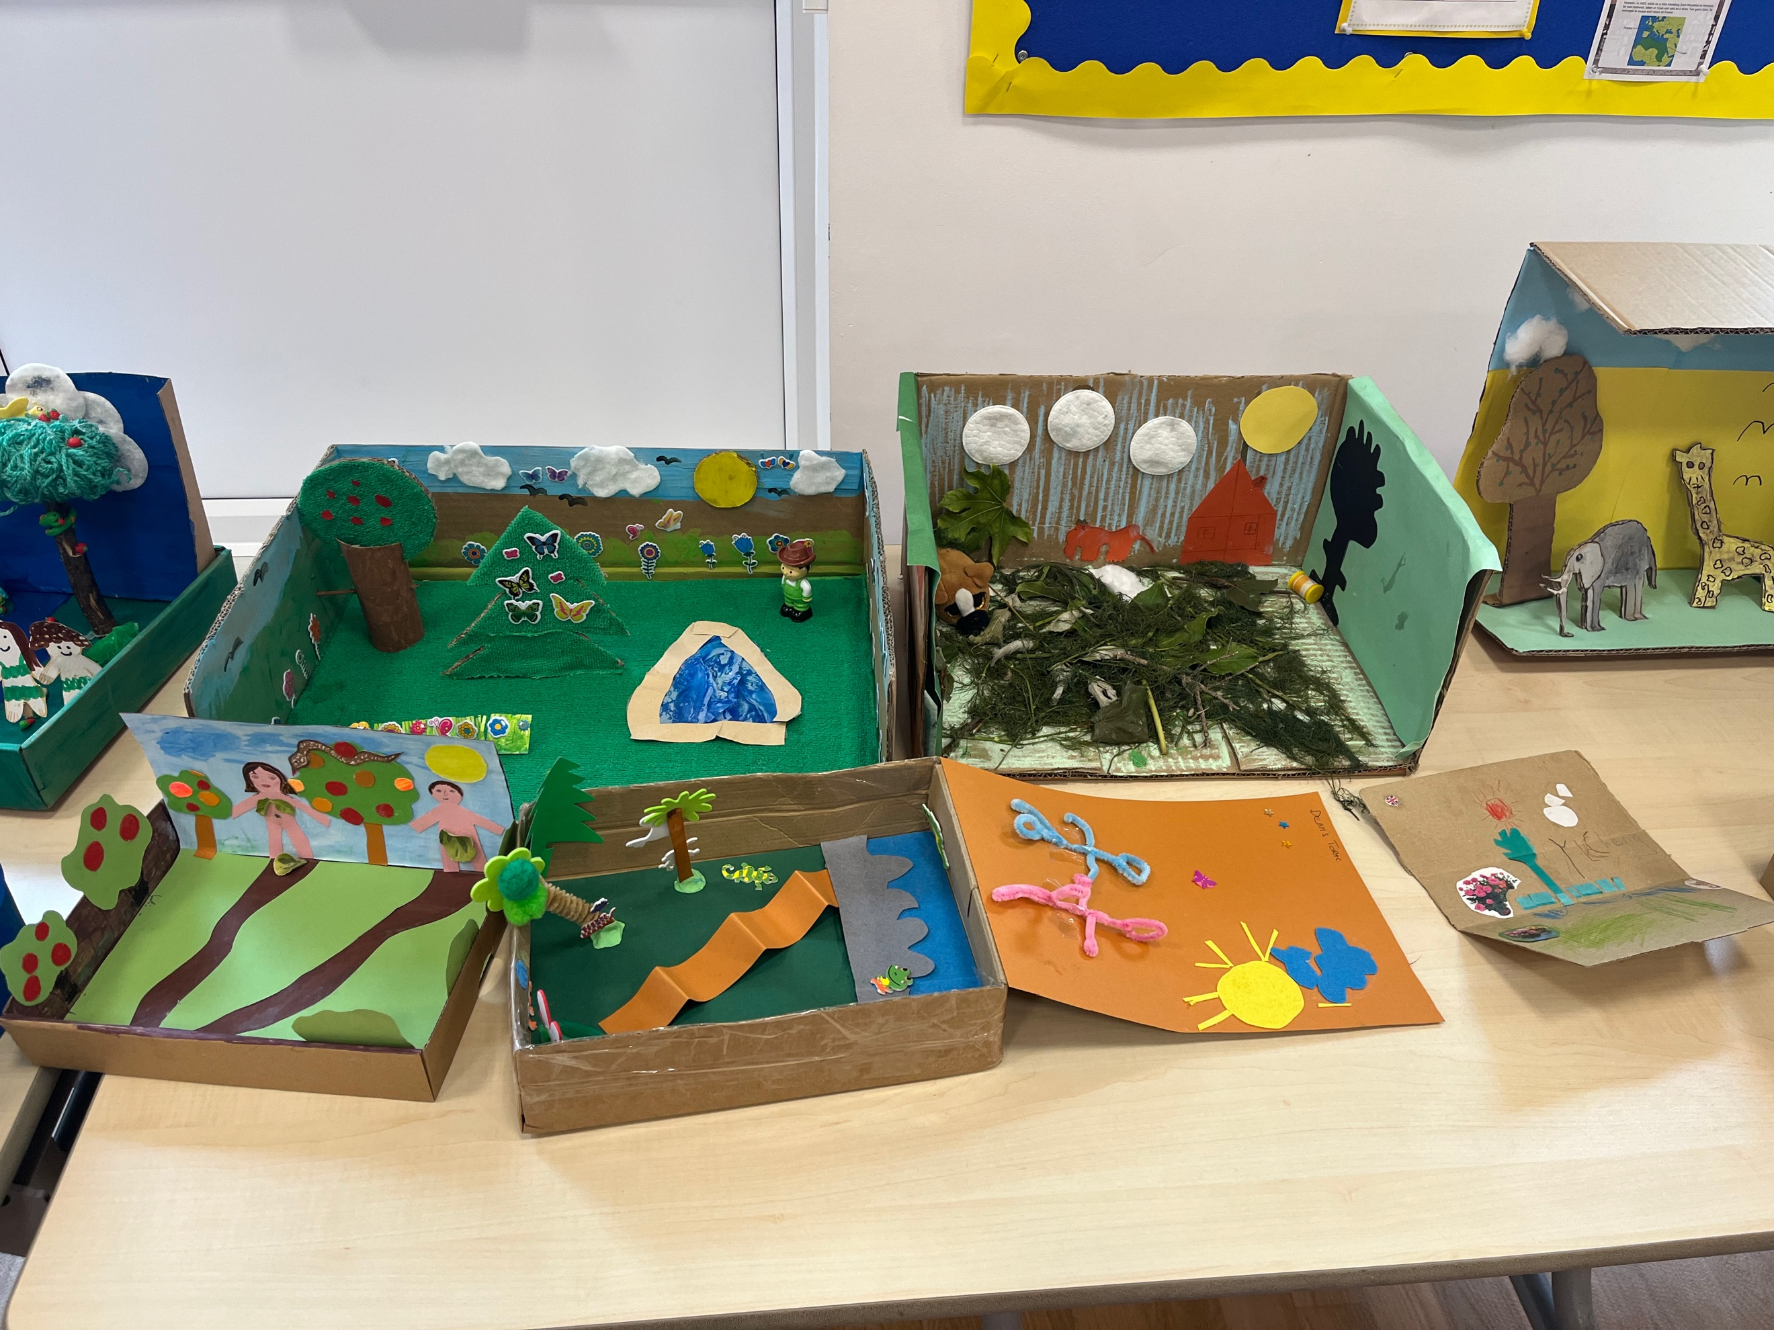
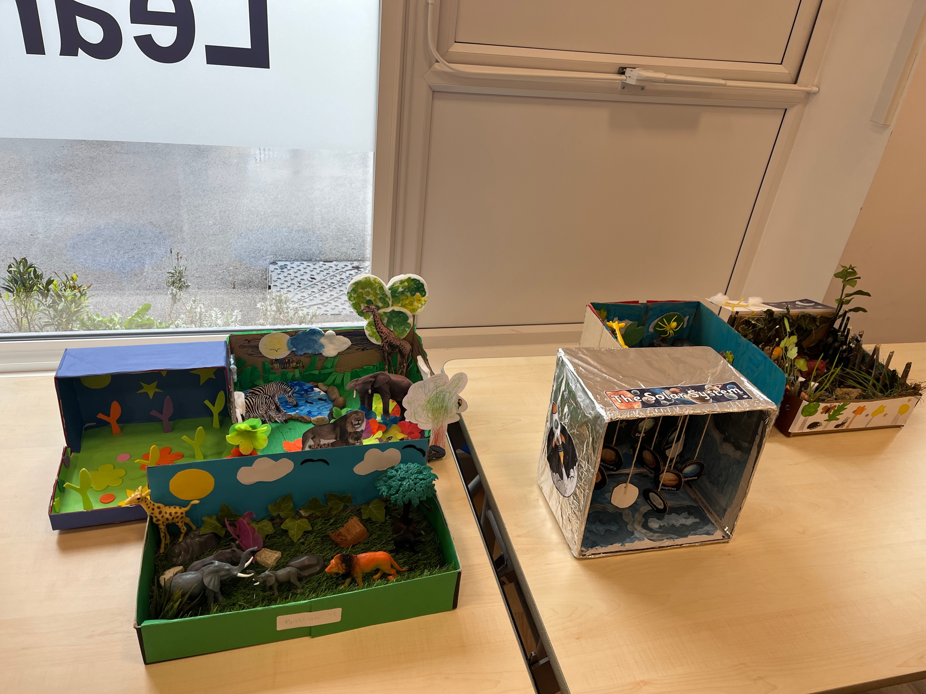
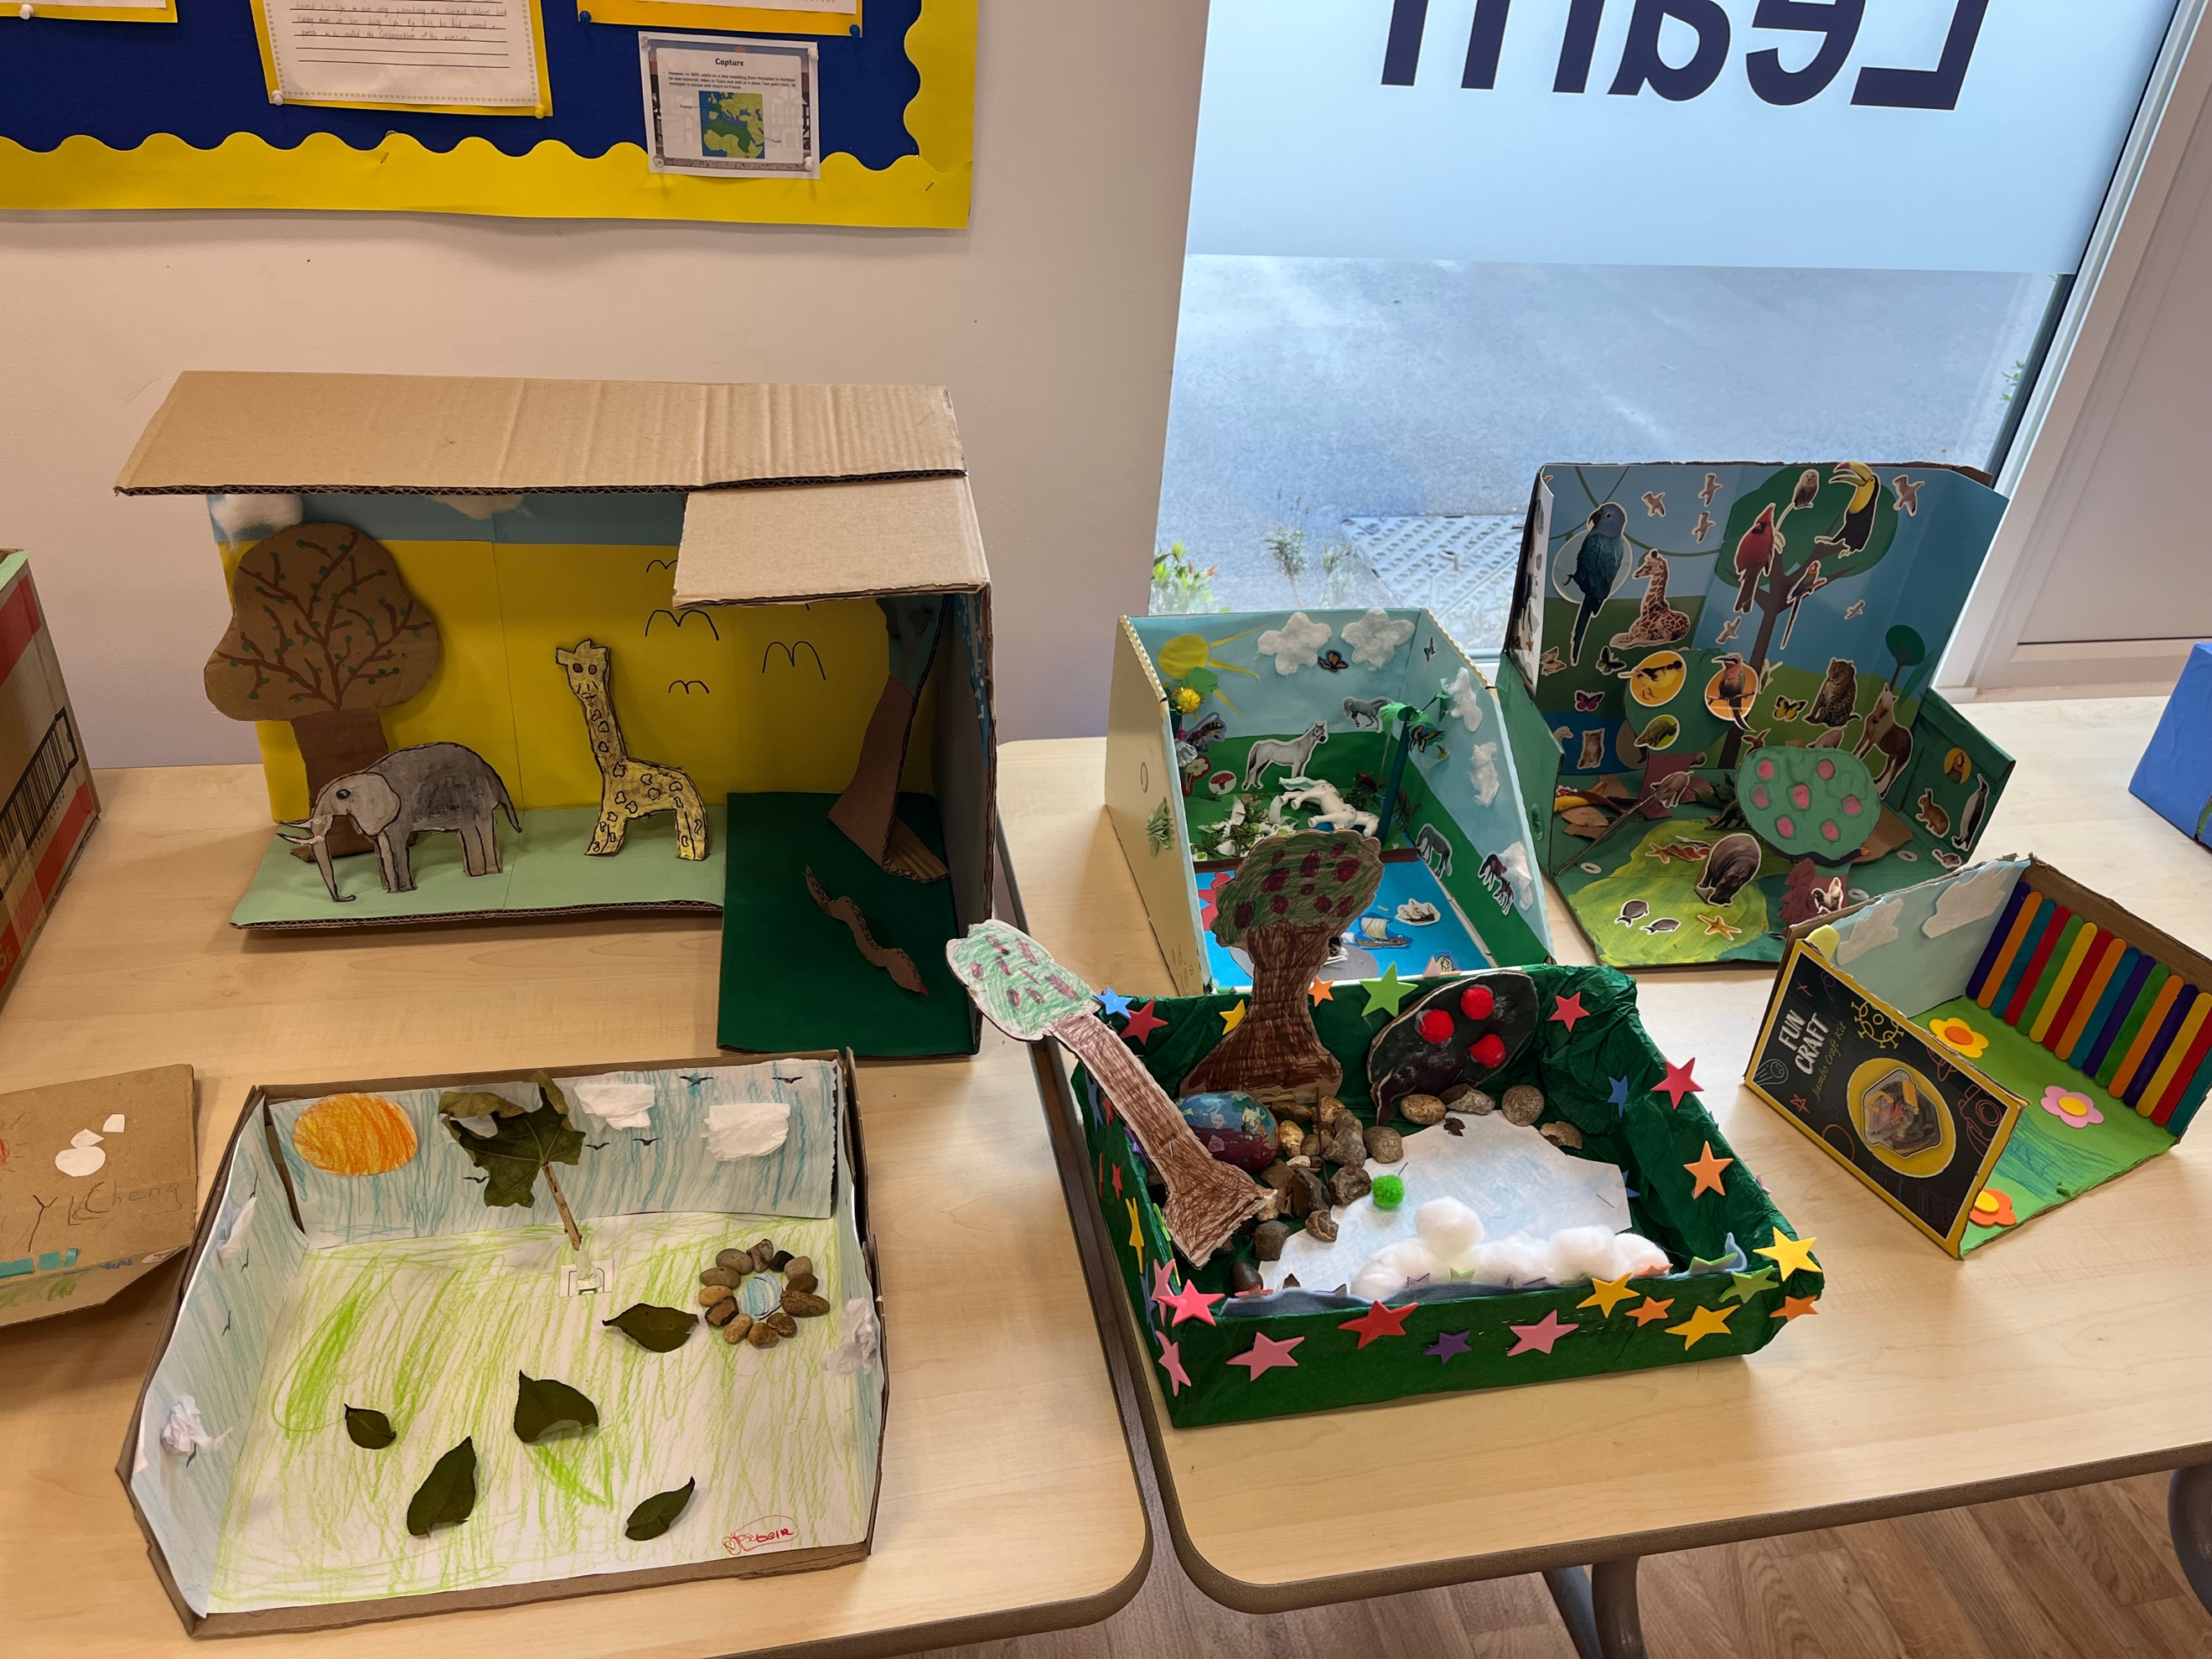

This term’s creative challenge is to Make your own Advent Wreaths (KS2) or
Make your own Nativity Scenes (KS1).

If you have any questions about this challenge, then please email sterry@clitherow.brent.sch.uk

RE NEWS

Please see below some photographs of the Pupil Chaplains ‘visit to Westminster and some of our lovely displays.
