RE NEWSLETTER –Autumn 1 2023
RE CURRICULUM TOPIC THIS HALF TERM -

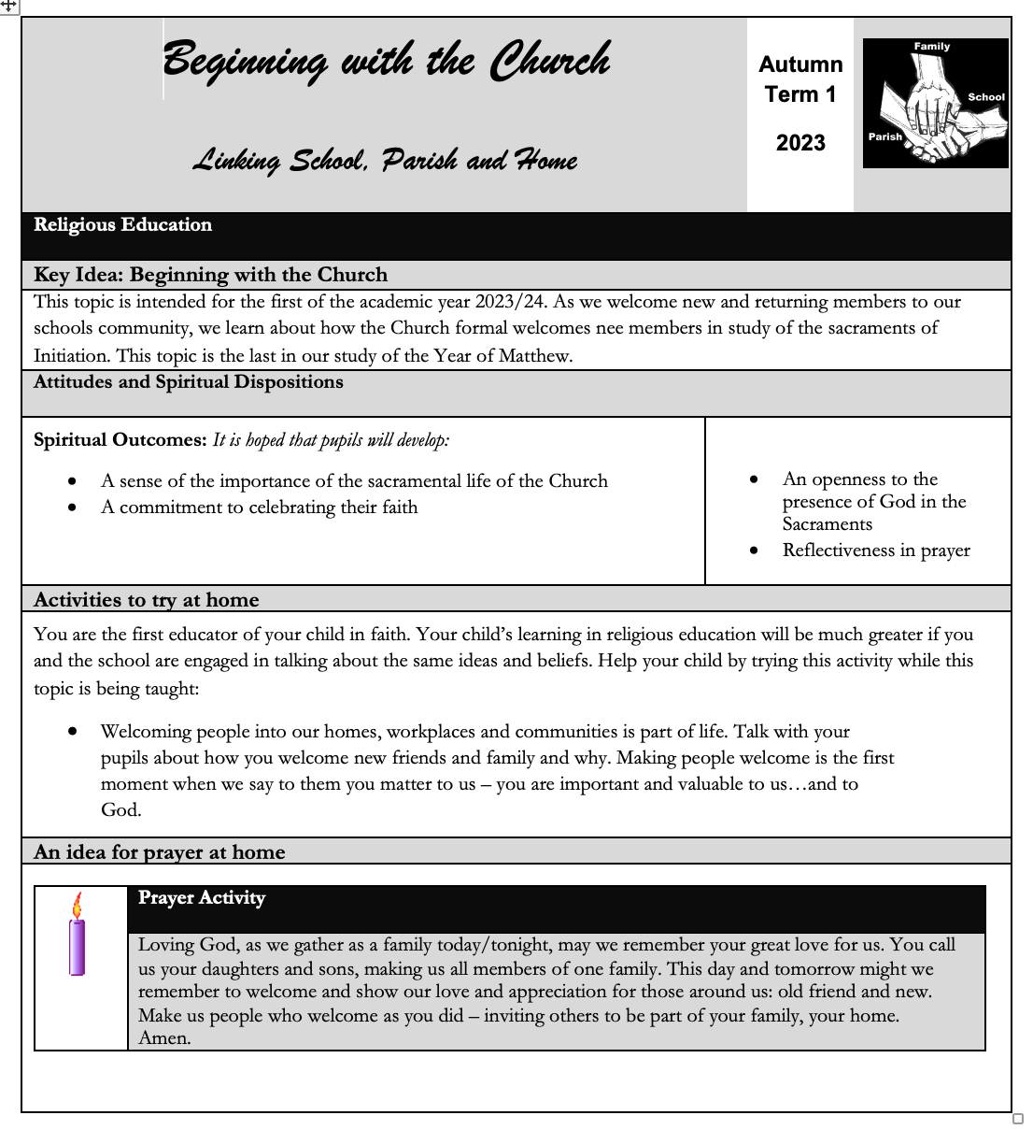

IMPORTANT DATES THIS TERM

8th September – Birthday of Blessed Virgin Mary
10th September – Education Sunday
14th September – Exaltation of the Holy Cross
15th September – Our Lady of Sorrows
21st September – St Matthew
24th September – Harvest Sunday
24th September – Our Lady of Walsingham
27th September - St Vincent De Paul
4th October – St Francis of Assisi
6th October – Harvest Fast Day
18th October – St Luke
22nd October - World Mission Sunday
22nd October – St John Paul II
24th October – World Mission Day

School Dates

14th September - Beginning of Year Mass
27th September - Year 5 Liturgy for St Vincent de Paul and own clothes day
4th October- Reception Liturgy for feast of St Francis and own clothes day
19th October – Tieing in Assembly

VALUES OF THE MONTH

This term the chaplains will be giving out special certificates for children displaying the value each week.

SEPTEMBER OCTOBER
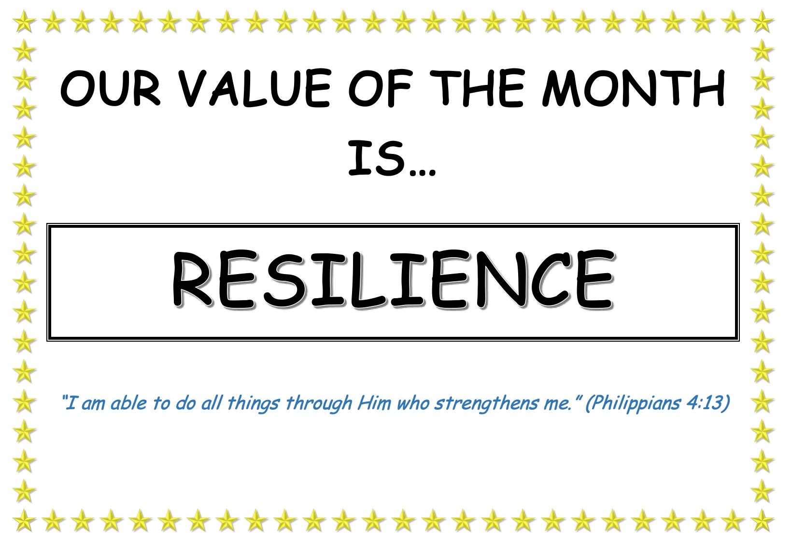

CLASS SAINTS

Reception – St Francis of Assisi
Year 1 – St Patrick
Year 2- St David
Year 3 – St Andrew
Year 4 – St George
Year 5 – St Vincent De Paul
Year 6 – St Martin de Porres

OTHER FAITHS

This term all classes will be learning about Judaism.

CARITAS IN ACTION

This year we will begin to use the new “Rooted in Love” programme created by Caritas Westminster. This is a new project to support schools with their journey in Catholic Social Teaching. The programme runs on a two-year rolling programme covering the following topics:
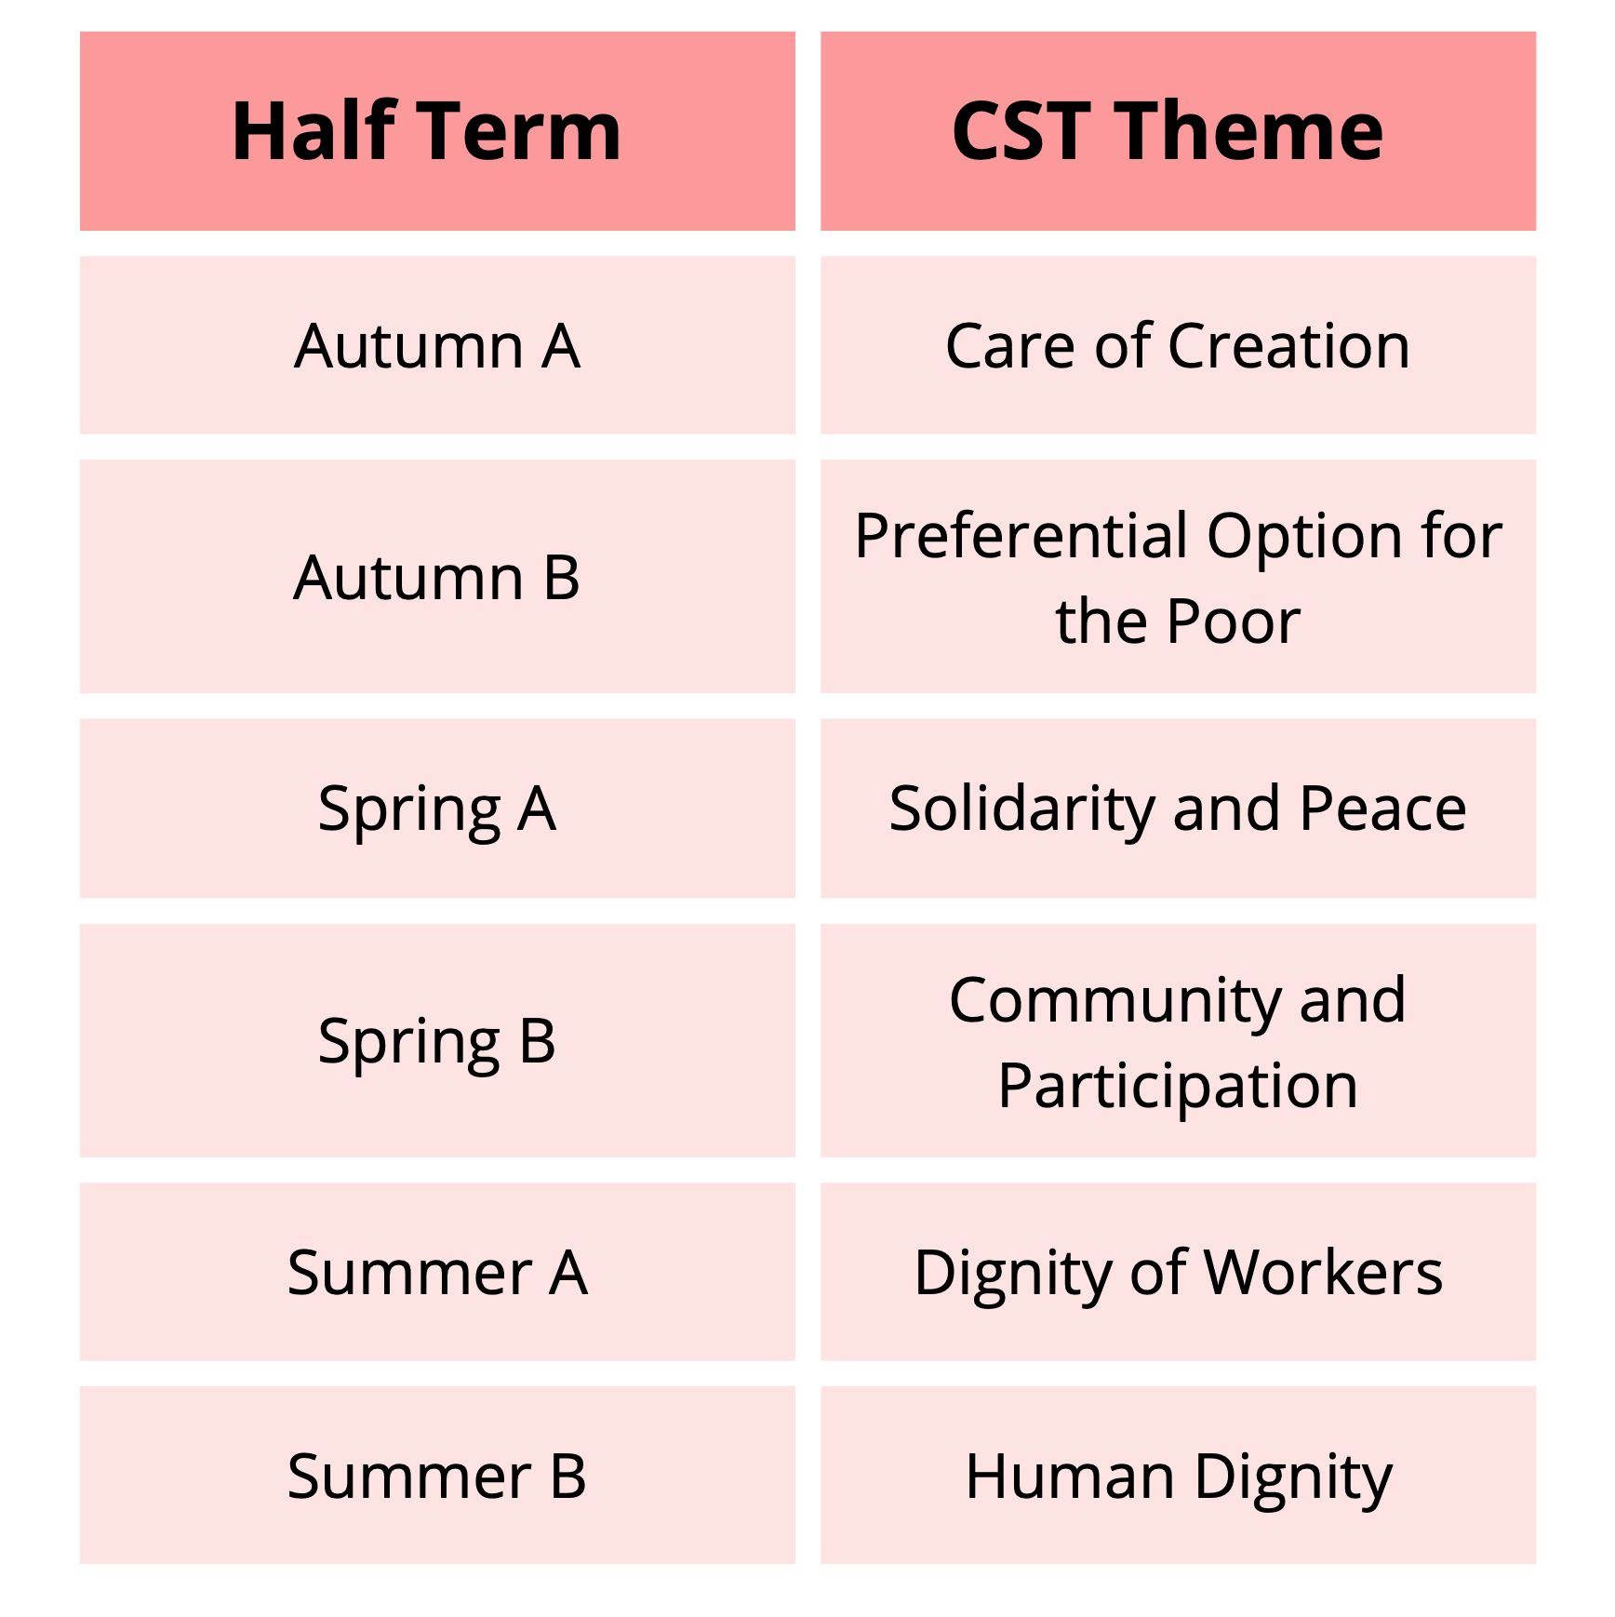

Our first topic is “Care of Creation”

PRAYER CYCLE

During Ordinary Time (Autumn), i.e. from September to Christ the King, we are asked to pray for these intentions:
Students and Teachers; The Spread of the Gospel; The Harvest; the Fruits of Human Work, and the Reverent Use of Creation; Justice and Peace in the World; All Victims of War; Young People; Prisoners and their Families.
PUPIL CHAPLAINS
Welcome to our New Pupil Chaplains who have been selected by the outgoing Chaplains based on an application and interview process. There was a large number of applications this year and we were very impressed with the standard of applications. Our 3 existing Year 6 Chaplains will stay in position to support the new members with their role.

Sama Y6

